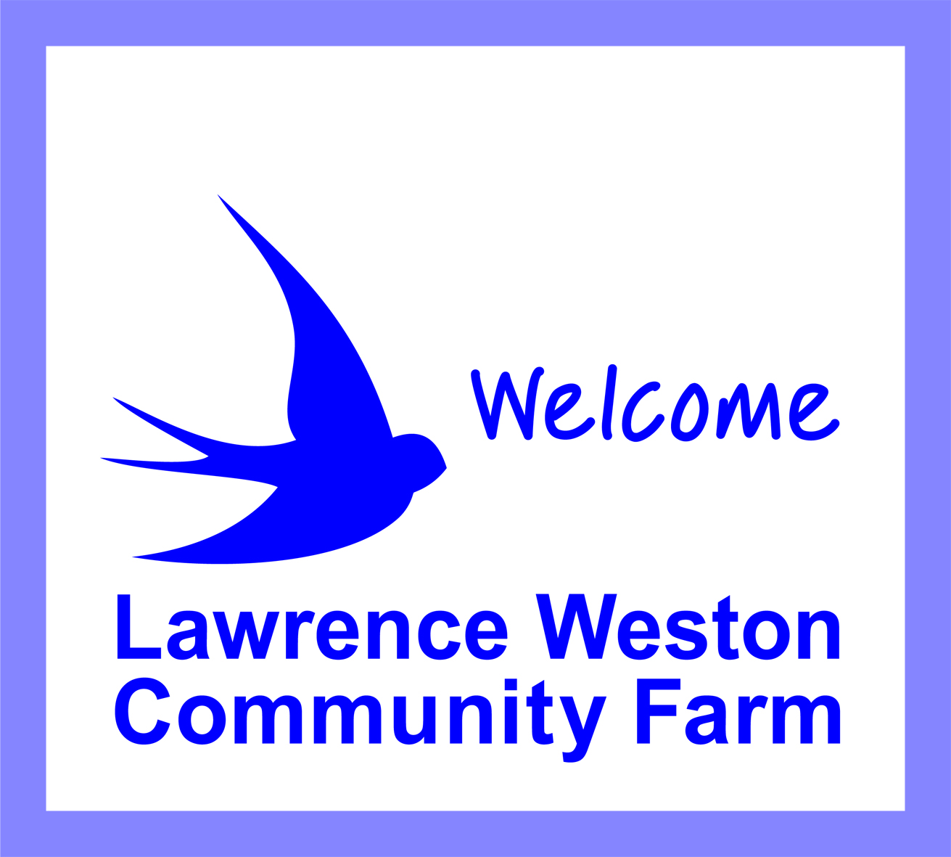 Membership Application Form:

Adult Individual Full Membership (over 18 years old)

Become a member and help to support the farm! Being a member helps us show funders that we have the support of the local community. Members can receive e- newsletters, preferential rates for room hire and courses and have the right to attend and vote at General Meetings and stand for election to the farm’s Management Committee.

Membership of the farm is annual and is free

Type of Membership | Tick
Adult Individual Full Membership
(18 years and over)

I would like to become a member of Lawrence Weston Community Farm.

Name ……………………………………......................................................................................................

Email (please write clearly) ....................................................................................................................

Address....................................................................................................................................................

...................................................................................................................................................................

Postcode........................................

Donations: We are always grateful for donations no matter how big or small.

I enclose a donation of £....................

I agree that the farm can store and use my data to provide me with services and communications.

I wish to receive e-newsletters and updates about farm events

You can unsubscribe at any time by either contacting office@lwfarm.org.uk or by clicking ‘unsubscribe’ at the bottom of our newsletters. You can also terminate your membership and have your data removed. Please contact the office on the above email or 0117 9381128
You can find our Privacy Policy on our website www.lwfarm.org.uk

Signature ………………………………….......................................... Date …………………………………

Please return to: Lawrence Weston Community Farm, Saltmarsh Drive
Lawrence Weston, Bristol, BS11 0NJ

Thank you for your support!

